CALL FOR SUBMISSIONS:
Community engagement for inclusive rural transformation and gender equality
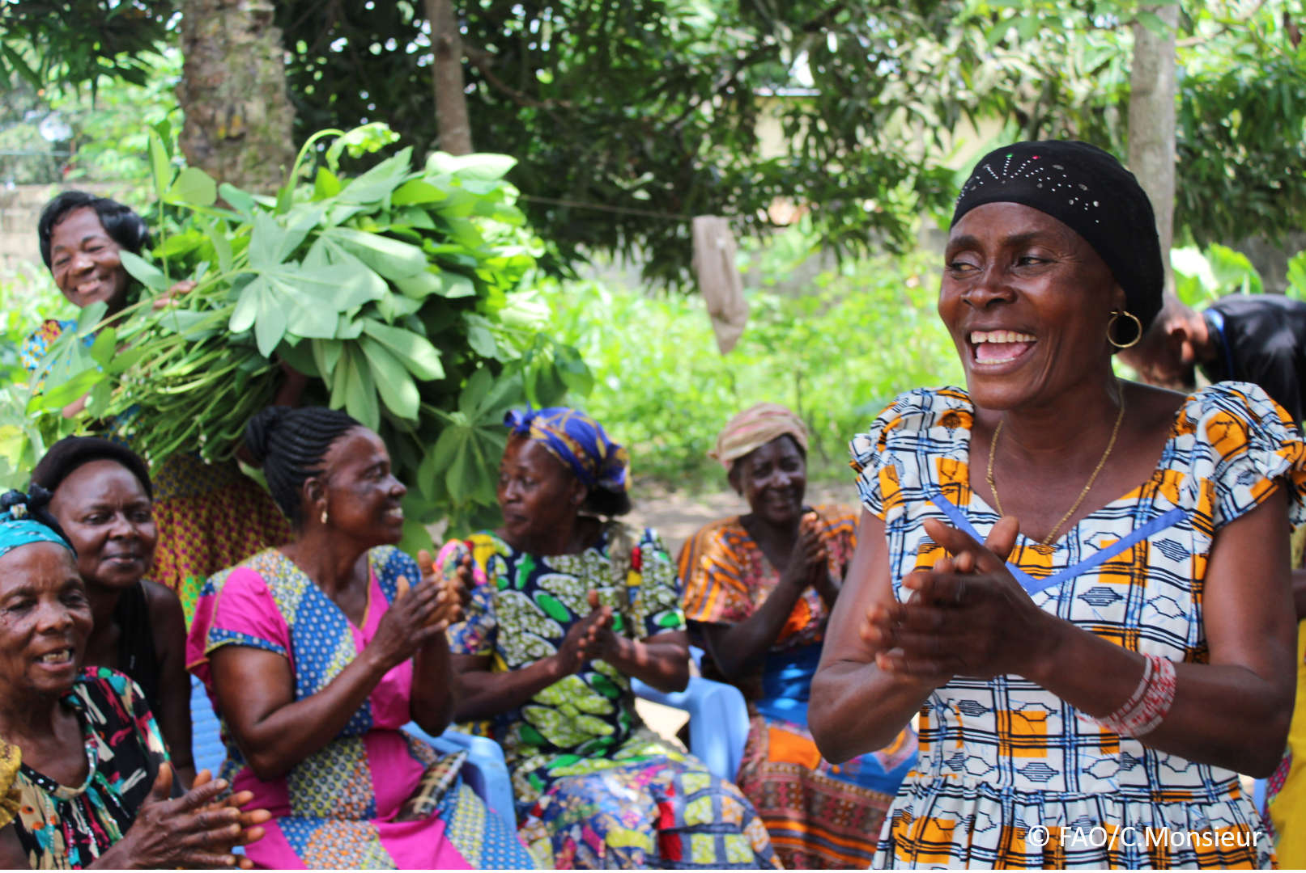
The objective of this call for submissions is to collect good practices, experiences, and lessons learnt on the use of community engagement for inclusive rural transformation and gender equality. The initiative, organized by the Rural Transformation and Gender Equality Division (ESP), seeks to gather insights from a diverse range of contributors, both within FAO and from external stakeholders. Its goal is to share knowledge, foster learning, and guide the scaling up of community engagement and community-led collective action to leave no one behind. The call builds on FAO's past efforts in this area, such as the Community Engagement Days series of webinars.
The call for submissions is open until 27 November 2024.

How to take part in this call for submissions:
To take part in this Call for submissions, please register to the FSN Forum, if you are not yet a member, or “sign in” to your account. Please review the topic note to understand the criteria we are considering for this call. If you wish to learn more about community engagement, you may refer to the background document. Once you have completed this submission template, upload it in the box “Post your contribution” on the call webpage, or, alternatively, send it to fsn-moderator@fao.org.
Please keep the length of submissions limited to 1,500 words and feel also free to attach relevant supporting materials.

Template for submissions

Contact person | Name: David Archer  Organization/Unit: ActionAid  Country: UK  Email address: david.archer@actionaid.org
Name/title of the good practice | The Reflect approach
Where is the good practice taking place? (Multiple selection allowed) | ☐ Europe and Central Asia  ☐ Latin America and the Caribbean  ☐ North Africa and Near East  ☐ Sub-Saharan Africa  ☐ Asia and the Pacific  ☐ North America  ☒ Global
Affiliation | ☐ Farmer and producer organizations  ☐ Trade Union  ☐ Informal community-based, farmer-based or self-help group  ☐ Research and academia  ☐ Government  ☐ Local/traditional authorities  ☐ Private Sector  ☒ Civil Society Organization  ☐ Intergovernmental Organization (e.g. UN system, World Bank)  ☐ Resource Partner/Donor  ☐ Other (please specify)
In which sector(s) and context (s) have you used this community engagement good practice? (Multiple selections allowed) | ☒ Education  ☒ Health and Sanitation  ☒ Food production in agrifood systems (please also tick the sub-categories)  ☐ Crop cultivation  ☐ Fisheries and aquaculture production  ☐ Livestock  ☐ Forestry  ☐ Agroforestry  ☐ Horticulture  ☐ Apiculture (beekeeping)  ☐ Agroecology and sustainable farming practices  ☐ Soil and water management  ☐ Other: ____________  ☒ Post-production in agrifood systems (please also tick the sub-categories)  ☐ Processing and value addition  ☐ Marketing and retailing  ☐ Transporting  ☐ Food loss and waste  ☐ Packaging  ☐ Storage  ☐ Distribution  ☐ Other _________  ☒ Gender Equality  ☒ Climate Action  ☒ Citizenship and Governance  ☒ Social Protection  ☒ Humanitarian and protracted crisis  ☒ Conflict resolution, peace and resilience  ☒ Digital innovation  ☐ Other sector (please specify) _________
Who are the financial partners supporting this good practice, if applicable? | The Reflect approach has been used by hundreds of organisations since it was first developed by ActionAid and this has been supported by a huge range of donors - INGOs, foundations, national governments, bilaterals and multilaterals
- In a few sentences, summarize your community engagement good practice.
The Reflect approach was developed by the international NGO ActionAid between 1993 and 1995 through a series of pilot projects in Uganda, Bangladesh and El Salvador, leading to the production of the Reflect Mother Manual in 1996. The approach originated from a fusion of the theoretical thinking of Brazilian educator Paulo Freire and the practical visualisation methodologies popularised through Participatory Rural Appraisal (see www.reflectionaction.org). The original intention was to use these methodologies for adult literacy programmes linked to ‘conscientisation’ but the approach rapidly evolved into one that was used in wider adult learning, participatory research and popular mobilisation processes. The approach has continued to diversify with various spin-offs, though efforts are now being made to reassert the common threads around the core reflection-action process.
One central element of Reflect was the intention to hand over to communities themselves the visualisation tools developed by participatory researchers, so that processes of research, analysis and change were almost entirely community-led, involving local people as facilitators, supporting participants to develop detailed surveys of their own communities – using maps, matrices, calendars, diagrams and other visual forms – and through this process to strengthen literacy and communication skills. Organisations implementing Reflect were encouraged not to impose their own agenda or priorities but rather to create space for communities to drive the process

- What problem(s) or challenge(s) does your good practice aim to address through community engagement?
- Reflect seeks to challenge the widespread problem of top down development initiatives where outsiders think they know what is best. Most development projects and programmes are led from outside by governmental or non-governmental agencies, largely ignoring the knowledge, experience and interests of communities themselves. The arrogance of thinking we know best what people need I an acute problem.
- The approach seeks to address whatever problems / issues the community themselves identify – and there is compete freedom for these to be identified and acted upon locally
- One of the recurrent problems addressed is the low levels of literacy and communication skills that constrain people’s capacity to assert their voice and articulate their demands.
- Another problem that Reflect seeks to address is the lack of sustainability of projects that are driven by outsiders and do not build ownership and capacity within communities.

- Describe your good practice in more detail. Include the main guiding principles, the desired changes or outcomes you aim to achieve (Theory of Change), and the key phases of implementation.

There were of course, from the start, many variations in Reflect practice, as there should be, based on the local context – and variations also influenced by the objectives and interests of the diverse organisations using the approach. However, in the early stages some of the crucial common elements of the Reflect approach were identified as:
- Local communities would nominate a facilitator from their own community based on criteria that were developed jointly by the implementing organisation and the community themselves. The facilitators needed to be respected themselves and respectful of all participants. Being local was crucial as this was about initiating an internal community process of research, learning and action, not one dominated or overly-mediated by outsiders (though we later analysed in more detail the extent to which practice depended on the nature, politics and objectives of the implementing agency).
- Training of facilitators was crucial – and needed to follow the same methods and philosophy as the Reflect process itself – so that trainee facilitators were using the same participatory tools to systematise their own knowledge and reflect on their own lives and issues, going through an empowerment process themselves. Most initial training would be for a few weeks but with a great primacy given to ongoing exchange and support between facilitators in neighbouring communities. The facilitators needed to be part of an ongoing research and action process themselves - which in some cases they would self-organise and in others depended on the implementing organisation
- The groups were called ‘Reflect circles’ and physical layout was important (not rows of desks but a democratic circle with the facilitator appearing as just another participant in the circle). There was a lot of discussion about how to ensure that circles were truly democratic spaces where everyone’s voice was given attention – and how to involve those who were more passive initially.
- The initial year of most Reflect programmes would involve developing 20 or 30 visualisations (usually maps, calendars, matrices, diagrams, rivers, trees etc.) – pulling together existing knowledge and experience on a wide range of issues, stimulating discussion and research, and adding up to a detailed survey and local development plan on everything from health to housing, agriculture to land tenancy, social structures to informal power relations, household gender dynamics to local history.
- There were at least two stages of dialogue which happened organically on each issue – a formative one as participants collectively constructed a large scale visualisation and then a summative one as participants reflected on the completed product that they had made together. There were important insights into how many people participated more comfortably in the dialogue processes because eye contact was on the task at hand, not on each other – and people were actively moving around not seated in a manner that would allow formal hierarchies to assert themselves. There was increasing attention to exploring power issues in all the discussions on every topic.
- Once the visualisations had been constructed on a large scale (often starting on the ground with sticks, stones, leaves, beans – any locally available material) they would be labelled with pictures (drawn by participants) and then translated to large sheets of flipchart paper). This transition from 3D to 2D is itself a fundamental step in literacy and the manual skills needed to draw with a pen help build skills needed for writing. The exact to approach to the literacy dimension depended on the levels of literacy within the group (often some would have basic literacy and others would have little or no literacy – in such cases peer support was encouraged).
- The written word would only be introduced once a visualisation was complete – and initially could introduce a few key words as labels or a whole written vocabulary on a theme. Sometimes specific help / peer support would then be provided to help those with the lowest literacy levels).
- After each topic, participants would identify actions that they could take to address the issues discussed – and in many cases these actions might include writing letters to people in authority – giving practical use to the literacy skills being developed. Letters would be collectively written with the facilitator as a scribe writing on flipcharts, so everyone could read what they had collectively written. Effectively participants were learning literacy in the process of writing their own, meaningful texts. Inevitably some participants learnt to write more quickly than others – though there was a lot of peer support and solidarity within groups to help everyone reach a basic level.
- After taking any action participants would reflect on what they learnt from the action – providing another stage of dialogue. Sometimes neighbouring Reflect circles would meet to discuss their analysis of an issue and identify large scale actions. Data was sometimes compiled across communities to build a larger evidence base for change – or to compare and contrast the different priorities and contexts that emerged. The core materials (both the graphics and associated texts) that were developed would always remain in the communities themselves – often in rolls of flipchart paper stored safely, that would be pulled out when needed. When we wanted to collect examples to share internationally, circles usually produced copies for us, keeping their originals as their own property.
- In some cases Reflect circles ended up collectively collating detailed surveys of their community and detailed community development plans – that they would then take to government agencies or NGOs – putting them in the driving seat. Other times they would produce critical analyses of existing development interventions and call for changes.
- The analysis of power was always at the heart of Reflect processes – both power dynamics within the group and community itself and power analysis more broadly within society and politics – always from people’s own perspectives.

The Reflect approach evolved very rapidly. Even as the pilots were underway in the three countries, people from other countries started to pick up on the approach. By the time we launched the Reflect Mother Manual in 1996 there were programmes in 20 countries and this then mushroomed to at least 70 countries by 2000 - and beyond that it was impossible to keep track. By having its own name or brand, Reflect was not restricted to ActionAid and was quickly picked up by many other international NGOs who used it with their partners. Some regional and national governments started to adapt the approach as did social movements, community-based organisations and people’s organisations. In the space of ten years organisations using the Reflect approach won 5 International Literacy prizes from UNESCO and Reflect evolved far beyond its initial focus on literacy.

- Who are the key actors and stakeholders involved in the design and implementation of the good practice, and what are their respective roles? Consider local partners, government, local authorities, community radios, civil society, research, the private sector, etc.

The actors and stakeholders can be very diverse depending on the implementing organisation and the local / national context – but the essence is that the community members are the primary actors. It is all about building local people’s own active agency and ability to hold other stakeholders to account.

- How does your intervention ensure inclusivity and equal and meaningful participation within the community?
Describe how your intervention includes and engages different groups within the community. Consider aspects like gender, age, ethnicity, disability status, livelihoods, and other specific conditions (e.g., people living in prolonged crisis, migrants, refugees). Explain how your intervention engages diverse segments of the rural community. Highlight the specific actions or strategies you use to reach these groups. If applicable, mention if your intervention uses specific approaches such as gender-responsive, gender-transformative, intersectionality, or other methods to ensure inclusivity and gender equality.
It depends on who is implementing Reflect and there are significant experiences of the approach being used specifically with refugees or migrants or internally displaced people – or indeed with disabled people’s organisations using the approach with people with disabilities. There are many contexts where there have been women-only groups or youth groups or groups convened based on their livelihoods (e.g. women small holder farmers or local market traders / informal sector workers / bonded labourers ) or based on their identity (Dalit groups, Indigenous people etc). In all these contexts, even where a Reflect circle has been convened with people coming from relatively homogenous groups, there is active encouragement for people to explore power dynamics within the group – which may be based on age, income, gender, ability, status, position. Building an intersectional lens of analysis, starting with people within the group themselves, can be very powerful.
- By using community engagement, what results and impacts have your good practice achieved?
Please provide specific examples and evidence demonstrating the effectiveness of your intervention, focusing on both qualitative and quantitative outcomes related to livelihoods and well-being improvements.

There have been many different evaluations of Reflect programmes in different countries

The evaluation of the first 3 pilot programmes, published by ODA (later DFIFD / FCDO) in 1996 can be found here: Action research report on REFLECT : Regenerated Freirean Literacy through Empowering Community Techniques : the experiences of three REFLECT pilot projects in Uganda, Bangladesh and El Salvador | Participatory Methods

There is also this consolidated review of 13 evaluations of Reflect (1) (PDF) A REVIEW OF 13 EVALUATIONS OF REFLECT

In most cases there are very strong finding relating to improved literacy and communication skills for people, greater self-confidence, increased collective action, improvements in livelihoods and incomes, a greater capacity to hold development actors to account, a capacity to influence local plan and budgets etc.
- Among these results, has the good practice led to improvements in terms of gender equality, women’s empowerment, and/or social inclusion?
Describe the behavioral changes in terms of gender that the good practice promotes, emphasizing agency, leadership, and participation in local governance. Include efforts to challenge discriminatory norms and unequal power dynamics. Highlight also how the intervention has supported the well-being (including psychological resilience) of marginalized groups and enhanced their inclusion and participation in decision-making processes.

Many of the evaluations referenced above show significant impacts in terms of changing attitudes and behaviours regarding gender roles and relations. Many Reflect participants and facilitators have gone on to be elected into local leadership positions.

- What key challenges did you encounter while implementing the community engagement activities, and how did you address them?
Include any resistance from communities, pushback, or issues related to unequal power dynamics, if applicable.

One of the most interesting challenges has been that organisations implementing a Reflect approach have sometimes found that they are directly challenged themselves by participants – demanding wider changes to he priorities and actions of the implementing organisation – to channel more funds to the priorities determined by communities themselves. This creates a challenge for organisations who have fixed plan and budgets and accounting and reporting systems. Often this leads to the need for institutional changes to ensure there is greater flexibility and responsiveness . This means taking on a Reflect approach and following it through cannot be taken lightly. Organisations need to be ready to reflect on their own power and adjust heir systems and procedures.

- What are the key lesson learned from your community engagement good practice?

Many lessons have been learnt over the years of Reflect practice but some of the key insights involve the importance of addressing the following elements for programmes to succeed
- You need to sustain a collective reflection-action cycle.
- It is important to draw from and adapt a basket of participatory tools and methods.
- Skilled local facilitators are essential and require ongoing support.
- Adopting a comprehensive power analysis with an intersectional lens is fundamental.
- You can use the Reflect approach in contexts where people are already literate but it is always good to integrate a dimension of strengthening communication skills (through language / technical skills / access to and use of diverse media / mean sof communication).
- It is important to integrate participatory monitoring and evaluation as part of the process and not as a separate extractive exercise.
- Has this practice been replicated in the same context or in different contexts?
What are the required conditions to replicate and adapt the practice in another context/geographical area?

By the time we launched the Reflect Mother Manual in 1996 there were programmes in 20 countries and this then mushroomed to at least 70 countries by 2000 - and beyond that it was impossible to keep track. By having its own name or brand, Reflect was not restricted to ActionAid and was quickly picked up by many other international NGOs who used it with their partners. Some regional and national governments started to adapt the approach as did social movements, community-based organisations and people’s organisations. In the space of ten years organisations using the Reflect approach won 5 International Literacy prizes from UNESCO and Reflect evolved far beyond its initial focus on literacy.

- How sustainable are the results achieved by this good practice?
Describe the key elements that need to be in place to make the initiative sustainable, including enabling environment (legal and policy frameworks and institutions), local ownership, accountability, etc.
Sustainability is at the heart of the Reflect approach because it is about people developing their own agency and capacity to achieve change, rather than being dependent on external actors or the whims of different funders. Shifts in power dynamics are key to sustainability.

- Based on the conversations FAO held during the Community Engagement days, a definition of community engagement for empowerment was proposed:

“Community engagement for empowerment and community-led collective action can be defined as an inclusive and participatory process that enables community members to become active agents of change in decisions affecting their lives, health, and environment. This process develops their capacity to achieve sustainable outcomes for improved rural livelihoods. Embracing a rights-based approach, it prioritizes the agency and participation of all community members, regardless of gender identity, sexual orientation, age, ethnicity, caste, socioeconomic status, political affiliation, migration status, or ability/disability. Indeed, inclusive approaches recognize the complexities of overlapping marginalization and discrimination that can exclude different community members from decision-making processes and implement strategies to foster their participation, agency and empowerment.”

We invite you to contribute to this definition. What would you add or change? Please share your thoughts, suggestions, and any additional elements you believe are crucial for a comprehensive understanding of community engagement approaches aimed at community-led collective action for inclusive rural transformation, people’s empowerment and gender equality.

Some reference to the need to shift visible, invisible and hidden power could be added

- Based on your experience, what gaps or areas for improvement still need to be addressed in the field of community engagement?

There is a continuous need for exchange of experiences between practitioners using this sort of approach as this helps to generate learning and new insights. Horizontal exchanges have proved most valuable

- What do you think is FAO's role in the field of community engagement? How can FAO support and enhance interventions like yours, if applicable? Consider aspects such as policy advocacy, capacity development, funding, technical assistance, knowledge production and sharing, and fostering partnerships.

FAO should look out for organisations using Reflect and similar participatory approaches and try to develop an ecosystem of support and connections between different practitioners. Many of the approaches hark back to the sort of practices supported by AO historically dating back decades to the old magazine Ideas and Action

Link(s) to specific references about your good practice (e.g. reports, communication products, videos, articles) | Please include attachment(s) or add here link(s) to documents/videos/podcasts/other with specific references.  - Stepping Stones Home - Stepping Stones and STAR  The original Stepping Stones training programme is a training package on gender, HIV, communication and relationship skills. It is also sometimes described as a social norms change training package, covering many aspects of our lives, including why we behave in the ways we do, how gender, generation and other issues influence this, and ways in which we can change our behaviour, if we want to. Stepping Stones was developed between 1993 and 1995, mainly in Uganda, working with a rural community. A convergence with the Reflect approach led to the development of STAR which focused discussions and activities on six broad areas 1) communication; 2) human rights; 3) reproductive health, family and community health; 4) power relations; 5) advocacy and 6) use of peer groups.  - Participatory Vulnerability Analysis - Participatory Vulnerability Analysis (PVA)  This resource helps to ensure that marginalised community members themselves lead the process in identifying their vulnerabilities – identifying local challenges, impacts of climate and other disasters and local capacities. The process encourages community members to then be active in planning and implementing solutions that work for them.  - Economic Literacy and Budget Analysis (ELBAG) – including work on influencing budgets – ELBAG resource on budgets (a guide for participatory budget work outlining the budget cycle, understanding revenue and taxes, ways of working with decentralisation and how to achieve local revenue justice) and work on deepening accountability in public services - ELBAG - accountability resource

The call for submissions is directly aligned with the thematic components of collective action within FAO's Programme Priority Areas (PPAs), specifically Better Life 1 (Gender Equality and Rural Women’s Empowerment), Better Life 2 (Inclusive Rural Transformation) and Better Life 3 (Agriculture and Food Emergencies).

